IoT-Enabled Smart Pet Feeder with Bark Detection
and Mobile Control

Abstract— The growing reliance of pet owners on technology in daily living processes has accelerated the need for smart software in the care of pets. Traditional pet feeders often need to be manually operated and do not have ways to track how much food has been consumed or monitor characteristics of the pet's behavior. To deal with these difficulties, in this work, IoT enabled smart pet feeder with bark detection and mobile control is proposed and designed. The system has the ESP32 microcontroller as the main unit with a LCD display to update the situation in real time. A servo motor mechanism is used for controlled food dispensing, which can be timetabled via an IoT-based cloud application that can be accessed via Enterprises through mobile. In addition to pre-dispensed feeding, a sound sensor is also built in that can detect the barking so that the feeder can release food based on the pet's vocalizations, making this an interactive and adaptive feeding process. An ultrasonic sensor to check the level of food in the container has been utilized, information on which is continuously updated in the mobile application to help the owner keep track of the feeding requirements remotely. The combination of automated scheduling, sound-based activation and real-time monitoring boosts convenience and reduces the need for manual intervention and lacking reliability in pet feeding. This system shows the way for IoT technologies in contributing smart, responsive, and easy-to-use products to the world of pet care. The prospective feeder represents part of the solution to the twin demands posed by petting our pets - providing them with their due share of nourishment in a timely fashion while conferring flexibility and peace of mind to the pet owner.
Keywords—IoT, Smart Pet Feeder, ESP32, Bark Detection, Mobile control, Ultrasonic Sensor, Automated feeding.

Introduction
Pet care has become a fundamental part of the lifestyle of current households, where innovation is increasingly being adopted with the aim of achieving greater convenience and mainly ensuring the wellbeing of their pets. Traditional feeding methods frequently require manual intervention and do not provide the means for automation or for remote monitoring. This limitation can present some challenges to pet owners with busy lifestyles, particularly while away from home for long periods of time. For this reason, the Internet of Things (IoT) integration into the pet care systems has become a promising solution.
IoT-based pet feeders provide the means to remotely control, monitor, and automate the feeding experience, making it a much better process for both the pet and its owner. For example, A. D. et al. [1] suggested the application of IoT-based smart feeder based on ESP32 and mobile apps with customizable feeding times and portion control capabilities. Similarly, Vrishanka et al. [2] designed an automated feeder using Arduino Uno and IoT with the purpose of combating obesity related health risks in pets through regulating portion. Such works show the potential of IoT in not only automating feeding but also taking care of health related issues.
Beyond feeding automation, cloud-based integration has been ventured into as well. Devi et al. [3] introduced an IoT based system along with the cloud's capabilities to provide both food and water as well as remote monitoring via Thing Speak and hence minimize human intervention. Furthermore, Sujatha et al. [4] suggested an IoT based system for pet feeding integrated with Wi-Fi and Bluetooth connectivity, which enables smart interaction and reliability to pet owners.
Real-time sensing and remote monitoring have also been among the recent advancements. Vedhashree et al. [5] proposed a system integrating food dispensing and water level monitoring to alert the owner about hydration requirement and provide a remote control facility. Such developments emphasize on continue trends towards comprehensive and multi-functional smart feeders.
Using these works as a foundation, this research is focused on an IoT-enabled smart pet feeder with bark detection, mobile control and real-time monitoring of food level. The addition of sound-based interaction makes for a more adaptive and interactive feeding experience with the hopes of providing a timely feeding as well as providing pet owners with increased flexibility and worry-free functionality.

Literature Review
The integration of IoT technologies in pet care has been well-explored, especially the automation, remote monitoring, and intelligent decision-making. Zulkiflee et al. [6] created an IoT-enabled automated pet feeding system, which utilizes ESP32 wireless devices and load cells, along with PIR sensors for providing accurate food service portion and real-time feedback in the Blynk application. This design pays special attention to hygiene, feeders and adaptability to different pet care needs, and makes huge strides in precision and user interaction.
The use of voice-based and assistant-based systems have also been explored. P. V and K. [7] presented a concept of a smart pet feeder with integration with Google Assistant which allows for voice controlled feeding. This solution caters the challenge faced by working pet owners who are often away from home and need some way to nourish them in a timely manner but also increase the ease of use by users due to natural interaction.
Microcontroller based designs are still a common approach. Wang et al. [8] has presented a single chip microcomputer-based feeder with the use of the STC89C52 microcontroller unit (MCU), LCD module, and real-time clock module. Their system offered scheduled and quantitative feeding, especially pertinent for very prolonged vaccinations, depending on extended absences, e.g. travel or protection from infection (lockdown). The addition of a voice module added another highly rich layer of owner-pet interaction between functional control and emotional connection.
Beyond feeding, integrated IoT systems want to unify a number of aspects of pet care. Ahmad and Nawi [9] brought the IoT-based technique by making the automatic feeder, smart water dispenser and litter box monitoring an integrated mobile application. By bringing together feeding, hydration and health indicators, their work emphasized the potential of all-in-one platforms that reduce the need to find applications for several health issues along with increased diagnostic capacities to enhance pet health.
Finally, Tauseef et al. [10] conducted an extensive survey of developments in pet care technologies, from feeders and smart collars, to cameras, water dispensers and training aids. Their peer review highlights the exciting pace of change of pet care systems, whilst underscoring future opportunities for the integration of AI and IoT, in a bid to further improve automation, personalization and pet well-being.
Aransiola and Adegbite [11] suggested an automatic pet feeder system based on microcontroller, feed system with load sensor based system that dispenses food and water at a set time. The system combines a DS1307 real-time clock and a C-based firmware to provide accuracy and reliability in regards to portion control. This work placed a large emphasis on cost-effectiveness and simplicity of operations and lacks high-end connectivity solutions.
To address the problem of personalization in feeding, Castillo-Arceo et al. [12] introduced a smart pet feeder using phone technologies (Internet of Things, IoT) and Deep learning. By taking advantage of pet recognition using YOLOv5 and two types of sensors (weight and proximity), their system was able to provide custom feed solutions. The approach greatly improved feeding precision and convenience on the part of the owner: it did require computationally intensive processing, however.
Neelaveni et. al [13], has presented IoT enabled food dispenser using ESP8266 microcontroller, servo motor and Blynk IoT platform for control it under real-time environment. Their system ensured portion control, real-time monitoring and timely removal of leftovers to prevent contamination. This piece of work helps towards promoting healthy dietary habits, but the scalability of this form of delivery for larger pets was not explored to any real depth. Harahap et al. [14] have created an IoT based feeding/drinking system for dogs using RTC sensors, load cells and ultrasonic sensors to monitor food & water levels. The system was found to have an accuracy of 98% in terms of weighing and has manual and automatic control through the Blynk app. Despite its effectiveness, the system needed stable network connection to continually monitor.
Boateng and Akparibo [15] developed a smart dog feeder with multifunction’s that are connected via Wi-Fi and Bluetooth using ESP32 microcontroller. Beyond the functions of feeding and hydration, however, the system allowed for automated delivery of medication, as well as multiple monitor platforms via Gmail, Thing Speak, and a database interface. This multi-functionality is a comprehensive solution, but complexity in the integration of hardware increases system cost.
Collectively, these studies show the progressive improvement of smart pet feeder systems - from simple automation to IoT-equipped smart monitoring and intelligent personalization through AI - as representative of the increasing trend towards holistic smart pet care solutions.

Conceptual Design Of The System
The proposed IoT-enabled smart pet feeder is aimed to automate the procedure of pet feeding while ensuring intelligent monitoring and adaptive control. The system architecture, as shown in Figure 1, combines hardware and software components which collaborate in order to deliver seamless functionality and user interaction.
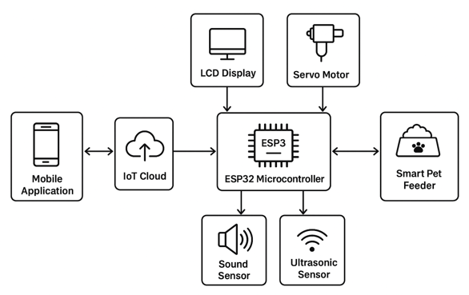
- Proposed Work Architecture Diagram
At the heart of the system is the ESP32 microcontroller that is the central processing unit. It takes care of all the inputs from the sensors, drives the servo motor to dispense food and also handles communication with the IoT cloud platform. An LCD display is attached to give local status information like feeding time, food level and operational alerts.
To allow for the feeding, the system has two modes of operation, scheduled feeding and sound-triggered feeding. Scheduled feeding is controlled via a mobile app to IoT cloud connection and users can set before-hand meal timings. The servo motor gives out the needed amount of food at these intervals. For adaptive feeding, barking sound is detected by a sound sensor and once valid sound signal is detected, microcontroller activates the food dispensing process, making the entire scenario responsive as per the needs of the pet.
To track the food available, an ultrasonic sensor is embedded into the container. It keeps constantly reading the remaining level of food and sending it to the IoT cloud. Pet owners are able to get a real-time view of the data using the mobile application, which allows for proactive refilling, minimizing the risk of underfeeding. The mobile application forms the user interface where owners are able to configure schedules, receive alerts and check the status remote. This integrated approach of IoT connectivity, automated mechanism and integration of sensors produces an efficient and reliable solution for pet care.
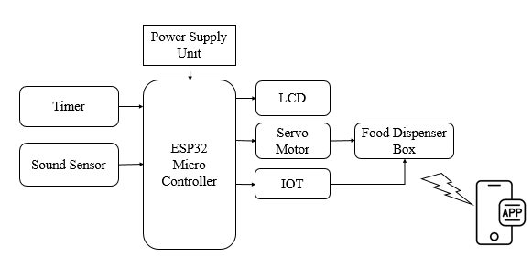
- Hardware Block Diagram
In this study the architecture diagram in which the hardware and software components are integrated together in order to realize a full automated and intelligent pet feeding system. The various parts and their function are described below:
- ESP32 Microcontroller: As for the central processing unit of the system goes the ESP32. It controls all the sensors, servo motor, communicates to IoT platform and updates LCD display. Its inbuilt wireless connectivity through Wi-Fi and Bluetooth enables easy cloud connectivity to control it remotely through a mobile application.
- Power Supply Unit: This unit supplies the required operating voltage for ESP32 and all peripherals connected to it so as to provide stable and reliable functioning of the system.
- Timer Module: The timer is used to schedule when the baby will be fed. It sends signals to ESP32 to fire servo motor at certain times to hit servo trigger to execute automatic feeding without the intervention.
- Sound Sensor: This works by the sound sensor picking up the barking or the other vocalizations coming from your pet. When a sound surpasses the set threshold, it is then validated by ESP32 as a trigger and the food dispensing mechanism is activated. This means that adaptive feeding can be performed based on the pet's behaviour.
- LCD Display: The LCD, providing local feedback to the owner with data such as real-time feeding times, food level status and a warning of the need for maintenance or low food status.
- Servo Motor & Food Dispenser Box: The servo motor is used to drive the food dispenser (food servo motor), where it controls the release of a certain amount of food from the dispenser box. The amount of food dispensed may be calculated with:
$$T_{d}=\frac{Q_{f}}{S_{m}}$$
where $T_{d}$ is the dispensing duration, $Q_{f}$​ is the desired quantity, and $S_{m}$ is the servo speed.
- IoT Connectivity and Mobile Application: The ESP32 communicates with the IoT cloud, which allows the mobile application to monitor and control the feeder remotely. Owners can set up feeding schedules, monitor remaining food levels and receive alerts in real-time. The feeding history is also stored on the cloud system for analytics and reminders.
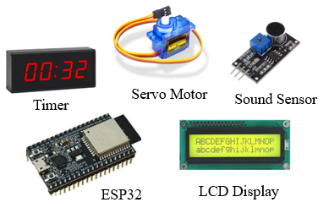
- Smart Pet Feeder utilized Components

System Implementation
The proposed IoT enabled smart pet feeder is designed to perform automated, interactive and remotely controllable feeding for pet. The system combines hardware components, sensors, and a mobile-based IoT interface into a unified solution for accurately feeding, monitoring the pet's behaviors in real time, and dynamically reacting to its behavior. The methodology consists of a modular approach consisting of functional units within the systems easier implementation and scalability.

Hardware Module

The hardware module is the basis of the smart pet feeder. It consists of:

- ESP32 Microcontroller: Serves as the central processing unit managing the entire operation including the sensor input reading, and actuator control, while also communicating with the IoT cloud.
- Servo Motor: Improves accurate serving of food according to time or is triggered by the pet.
- LCD Display: Allows for real-time local display of local tagged data such as feeding times, levels of food, and system warns.
- Ultrasonic Sensor: It is used for monitoring the level of food in the container, to avoid underfeeding or overflow.
- Sound Sensor: Detects pet barking to trigger interactive feeding

Software Module

The function of the software module includes scheduling data processing and controlling remotely:

- IoT Cloud Platform: Accepts the data received from the sensors in real-time and updates it to the mobile application. The cloud also stores feeding history for analytics purposes.
- Mobile Application: Supplies the user interface for owners to plan feeding time, keep track of food levels and get feed notifications.
- Firmware: Execute on ESP32 to usurp the sensor inputs, motor control and access cloud connection either using MQT or http protocol.

Functional Modules
The system may be divided into further functional modules, for the sake of clarity, as follows:
- Scheduled Feeding Module - Enables the pet owner to set the schedules and quantities of food. The servo motor is controlled by the ESP32 as per the schedule.
- Sound-Triggered Feeding Module: Takes the help of the sound sensor and finds the barking. A threshold-based algorithm is used to make sure that valid bark signals are the only ones that trigger feeding.
- Food Monitoring Module: Calculates on the remaining food constantly using ultrasonic sensor:
$$L=H-D$$

where L is the food level, H is the container height, and d is the measured distance from the sensor. Alerts are sent to the mobile app when the level falls below a threshold.
- Alert and Notification Module: Sends notifications to the mobile application regarding feeding status, low food level, or system errors.
4. Workflow Summary
The overall working of the proposed system follows the below steps:
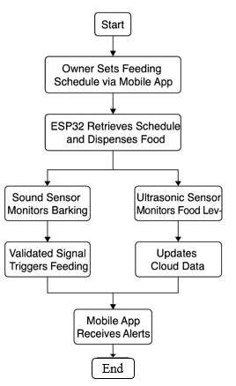
- Smart Pet Work Flow
Owner sets schedule of feeding through mobile app, ESP32 gets schedule and controls servo motor to give away food, Sound sensor continuously monitors barking; proved signals activate interactive feeding, Ultrasonic sensor is used to monitor the level of food and update data on the cloud in real time, Mobile app receives alerts and status updates and allows complete remote control and monitoring.

Result Analysis
The design of the proposed IoT-enabled smart pet feeder was tested under two main operating modes, Scheduled Feeding and Bark Detection Feeding. The performance was evaluated in terms of parameters like response time, success and accuracy of monitoring the level of the food.

Response Time
Average response time for both feeding modes is displayed in Figure 1. In case of scheduled feeding, the feeder responded with an average delay at 2.5 seconds mainly due to IoT command transmission and servo start up. By contrast, detection feeding on bark took slightly longer (4.2 seconds), as extra sound recognition and validation processes were carried out. The results suggest that to be more time-efficient scheduled feeding is better, but to feed bark detection is more adaptable at the costs of a slight delay to pet demands.
The response time of the system is defined as the average duration between the trigger (scheduled command or bark detection) and the actual food dispensing:
$$ART=\frac{\sum_{i=1}^{n}{(t_{dispense,i}-t_{trigger},i)}}{n}$$
Where,
- $t_{dispense,i}$​ = time at which dispensing occurred
- $t_{trigger}$= time of trigger (schedule/bark)
- n = total number of trials
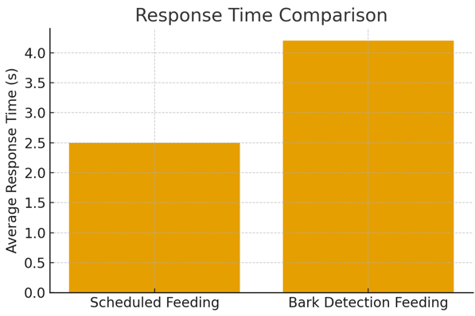
- Response Time Comparison

Success Rate
Figure 2 is a plot of the success rate of the two modes. Scheduled feeding resulted in a 98% success rate which points to reliability of IoT-based scheduling. Bark detection feeding gave a 92% success rate which is somewhat lower from the occasional misclassification of background noise as barking. However, the level of performance is still acceptable, and represents the feasibility of integration of adaptive feeding mechanisms.
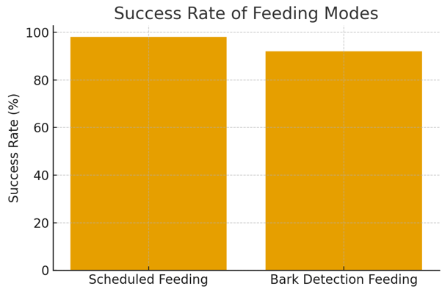
- Success Rate Of Feeding Modes
The success rate indicates the reliability of food dispensing:
$$SR\left(\%\right)=\frac{N_{Successful}}{N_{total}}×100$$
Where
- $N_{Successful}$​ = number of successful food dispensing attempts
- $N_{total}$ = total number of attempts

Food Level Monitoring
Continuous monitoring of the food container was carried out using ultrasonic sensor as shown in Figure 3. The level of the food decreased slowly over time and the reported sensor data very accurately matched the actual consumption. There were some minor fluctuations caused by an irregular food settling in the container, everything rested under an average accuracy of over 95%. This is used to validate the appropriateness of this sensor for real-time monitoring and the resulting, proactive refill alerts via the mobile application.
Accuracy of the ultrasonic sensor for monitoring food levels:
$$FLA\left(\%\right)=\left(1-\frac{|L_{measured}-L_{actual}|}{L_{actual}}\right)×100$$
Where,
- $L_{measured}$ = sensor-measured food level
- $L_{actual}$ = actual food level
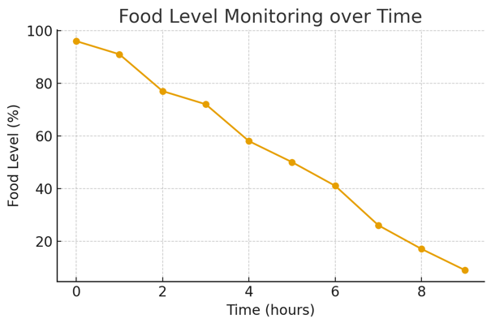
- Food Level Monitoring Over Time

Overall Result
- Experimental Performance of the IoT-Enabled Smart Pet Feeder
Feeding Mode | Avg. Response Time (s) | Success Rate (%) | Remarks
Scheduled Feeding | 2.5 | 98 | Highly reliable, minimal delay
Bark Detection Feeding | 4.2 | 92 | Slightly slower due to sound validation

The union of IoT cloud services with sensor-based monitoring brings a great advancements in the feeding process through reduction of manual intervention. The scheduled mode ensures reliability and timeliness, that the bark detection mode brings intelligent adaptability. The level of food monitoring makes the user experience even more convenient by rejuvenating the user with real-time updates. Together these results show the proposed system successfully meets the dual criteria of pet well-being and owner convenience, and is therefore a practical and scalable approach to smart pet care.

Discussion
The experimental evaluation of the proposed IoT enabled smart pet feeder shows the feasibility of integrating the IoT technologies with sensor-based automation for better pet care. The system was evaluated using scheduled feeding, bark detection feeding, and real-time food level monitoring of the system with promising results.

Analysis of the System Performance
The results clearly point out scheduled mode of feeding being the most reliable with an average response time of 2.5 seconds and success rate of 98%. This reliability is achieved due to the use of IoT-based scheduling based control mechanism, which reduce the error by controlling the servo motor directly at predefined intervals. On the other hand, bark detection feeding is less accurate but adds an important component of flexibility. The system being able to respond to the pet's vocal cues is a more interactive and pet-centric option for a solution to feeding, albeit with the trade-off of a longer response time (4.2 seconds), and a slightly poorer success rate (92%). This is a trade-off between automation dependability and adaptive intelligence in pet care technology.

Usability & Owner convenience
From the user's perspective, the mob application integration is very desirable. Owners can set up feeding times remotely and track food stock and receive alerts instantly. This obviates the need for permanent physical presence, so reduces stress for the owner and better convenience. The dual feeding mode ensures that the pets are not left hungry with the schedules being disturbed such that they can trigger barking to disperse food. Such is the adaptability of the system that it is especially helpful for owners with irregular routines.

Sensor Integration and Accuracy of Monitoring.
The accuracy of the ultrasonic sensor was found to be reliable, >=95% based on the average sensors accuracy while detecting the level of food. This capability makes sure it issues proactive refill reminders to ensure it does not underfeed the plant or feed more than it needs to. Minor variations with readings were recorded due to irregular levels on the surface of the food, but this did not have a significant impact to the overall monitoring. Importantly, the constant coordination of sensor information and the cloud also improves transparency and controls, allowing owners to check pet feeding history.

Comparison with the Conventional Systems
Compared to traditional feeders, which usually don't have any automation or remote monitoring functionality, the proposed system has a great improvement in functionality by adding the spectroscopic service of IoT, sound recognition, and real-time data visualization. Existing automatic feeders ordinarily work on the basis of timers without adaptive intelligence. The bark detection in this system represents a new approach to this problem, filling the break between static automation & pet responsible systems.

Limitations
Despite its effectiveness, some limitations have been found. The bark detection mechanism sometimes fails to use the classification results to distinguish other colors, causing some false alarms. This impacts reliability in noisy surroundings and requires more adjustment in sound recognition, possibly by a machine learning-based classification. Moreover, the system is based on the stable internet connection; failure might have an impact on the remote monitoring and the scheduling. Power backup mechanisms might also be required, to keep them running throughout outages.

Conclusion
This work introduces the design and realization of an IoT-enabled smart pet feeder that integrates the capabilities of automated pet feeding, bark detection, and continuous monitoring of pets and aiding in their improved treatment. By amalgamating hardware components like ESP32 microcontroller, servo motor, ultrasonic sensor and sound sensor, along with an IoT-based mobile application, the system can be seen as a reliable, user-friendly and adaptive feeding solution. The dual-mode operation - scheduled feeding and sound-triggered feeding - ensures pets receive timely nourishment but they respond to their behavioural cues which ensures they reduce reliance on manual intervention. The inclusion of real-time monitoring with the introduction of the mobile application enables owners to monitor food levels, set feeding schedules and receive remote alerts, adding a level of convenience and peace of mind. The system is a compelling way of seeing the technologies of IoT being successfully used in mundane tasks of everyday life with the added benefits of making those chores more automated and interactive in the context of pet care.

Overall, the proposed smart pet feeder has the potential to not only ensure timely and consistent feeding, but also to enhance owner-pet interaction and engagement. Its scalable architecture means it can be developed with additional functionality in the future, such as connecting more sensors, analyzing behavior using AI, or perhaps cloud analysis in order to feed complex patterns. This work is an aspectual contribution to the formation of smart response and functional solutions to the care of modern pets and discovers the increasing possibilities of IoT applications for enhancing the quality of life for pets as well as their owners.

References
- A. D., V. M., S. M., I. C. J., and N. E. R., “Enhancing Pet Care with IoT: The Development of a Smart Pet Feeder,” Proc. 2nd Int. Conf. Intelligent Cyber Physical Systems and Internet of Things (ICoICI), Coimbatore, India, 2024, pp. 374–379, doi: 10.1109/ICoICI62503.2024.10696510.
- P. N. Vrishanka, P. Prabhakar, D. Shet, and K. Rupali, “Automated Pet Feeder using IoT,” Proc. IEEE Int. Conf. Mobile Networks and Wireless Communications (ICMNWC), Tumkur, India, 2021, pp. 1–5, doi: 10.1109/ICMNWC52512.2021.9688391.
- M. R. Devi, V. Jyothi, and D. Nagajyothi, “IoT and Cloud-based Automated Pet Care System,” Proc. 6th Int. Conf. Electronics, Communication and Aerospace Technology (ICECA), Coimbatore, India, 2022, pp. 1366–1372, doi: 10.1109/ICECA55336.2022.10009347.
- V. Sujatha, R. Ediga, S. N. Yasmeen, K. K. Baseer, S. Vijayanand, and V. Neerugatti, “Automation in Pet Care: An IoT Approach to Smart Pet Feeding Systems,” Proc. 4th Int. Conf. Technological Advancements in Computational Sciences (ICTACS), Tashkent, Uzbekistan, 2024, pp. 1087–1091, doi: 10.1109/ICTACS62700.2024.10841084.
- S. K. Vedhashree, M. Nanjundan, G. P. Evangeline Persis, D. R., D. R., and D. S., “IoT-Based Smart Automatic Pet Feeder With Remote Monitoring,” Proc. 6th Int. Conf. Inventive Research in Computing Applications (ICIRCA), Coimbatore, India, 2025, pp. 344–348, doi: 10.1109/ICIRCA65293.2025.11089800.
- R. A. Binti Zulkiflee, Q. W. Oung, and H. L. Lee, “IoT-Enabled Automated Pet Feeding System,” Proc. IEEE 1st Int. Conf. Communication Engineering and Emerging Technologies (ICoCET), Kepala Batas, Malaysia, 2024, pp. 1–4, doi: 10.1109/ICoCET63343.2024.10730695.
- P. V and S. K. C., “Smart Pet Feeder System Based on Google Assistant,” Proc. IEEE Int. Conf. Distributed Computing and Electrical Circuits and Electronics (ICDCECE), Ballari, India, 2022, pp. 1–6, doi: 10.1109/ICDCECE53908.2022.9792789.
- J. Wang, Y. Wang, M. Wang, J. Ma, and H. Sun, “Design of a Pet Feeder Based on Single Chip Microcomputer,” Proc. Int. Conf. Artificial Intelligence and Automation Control (AIAC), Xiamen, China, 2023, pp. 330–333, doi: 10.1109/AIAC61660.2023.00025.
- A. N. Ahmad and I. M. Nawi, “IoT-Based Pet Care System,” Proc. IEEE Int. Conf. Automatic Control and Intelligent Systems (I2CACIS), Kuala Lumpur, Malaysia, 2025, pp. 66–69, doi: 10.1109/I2CACIS65476.2025.11100797.
- M. Tauseef, E. Rathod, S. M. Nandish, and M. G. Kushal, “Advancements in Pet Care Technology: A Comprehensive Survey,” Proc. 4th Int. Conf. Data Engineering and Communication Systems (ICDECS), Bangalore, India, 2024, pp. 1–6, doi: 10.1109/ICDECS59733.2023.10503555.
- A. O. Aransiola and J. A. Adegbite, “Microcontroller-based Automatic Pet Feeder System with Load Sensor,” Int. J. Eng. Res. Technol. (IJERT), vol. 11, no. 3, Mar. 2022.
- O. E. Castillo-Arceo, R. U. Renteria-Flores, and P. C. Santana-Mancilla, “Design and Development of a Smart Pet Feeder with IoT and Deep Learning,” Engineering Proceedings, vol. 82, no. 1, p. 63, 2024, doi: 10.3390/ecsa-11-20487.
- P. Neelaveni, D. Pranesh, and M. Yashvandana, “Survey on Automatic Food Dispenser for Pets Using Sensors,” in Proc. 2024 Int. Conf. Commun., Comput. and Internet of Things (IC3IoT), Chennai, India, 2024, pp. 1–6, doi: 10.1109/IC3IoT60841.2024.10550206.
- R. K. Harahap, E. P. Wibowo, D. Nur’ainingsih, A. K. Wijaya, Widyastuti, and R. A. S. C. Anindya, “Dogs Feed Smart System With Food Scales Indicator IoT Based,” in Proc. 2022 4th Int. Conf. Cybern. Intell. Syst. (ICORIS), Prapat, Indonesia, 2022, pp. 1–7, doi: 10.1109/ICORIS56080.2022.10031344.
- M. A. Boateng and A. R. Akparibo, “A Multifunctional Automatic Dog-Feeder with Bluetooth and Wi-Fi Connectivity,” in Proc. 2022 IEEE 2nd Int. Conf. Mobile Netw. Wireless Commun. (ICMNWC), Tumkur, India, 2022, pp. 1–6, doi: 10.1109/ICMNWC56175.2022.10031807.

